Socio-technical perspective
Name
Institution
Course
Instructor
Date
The insights provided by social sciences have been recognized in health informatics. It has helped in promoting a better understanding of the information systems based on the interaction between technology and the social environment. The socio-technical approaches are applied in healthcare to help in understanding the development of information technology, its introduction to a healthcare organization as well as implementation making it part of the social processes. The socio-technical approaches examine the healthcare work treating it as a real-life phenomenon, the implementation of technological systems. The approaches have been used in improving the designs and implementation of various systems.

Health and clinical care
The healthcare works such as the interaction with the data or information technology are viewed as a social process from the socio-technical perspective. There is simultaneous interaction with different individuals with different health needs as well as the interaction between different organizational units. The socio-technical view of social work as a real-life social phenomenon is intended to promote a better understanding of all healthcare constituents. An example entails decision-making or giving and execution of orders within the organization. The socio-technical perspective explains the significance of cooperation among nurses, doctors, and physicians in making different decisions. The healthcare service providers require various materials for inpatient treatment. The interaction with various materials helps the service providers in organizing and restructuring their work while promoting sustainability within the organization.

Organizational theory
Healthcare services are provided in a social setting. The organization includes various hierarchies in leadership, competitions, histories, or even culture. The implementation of the various information technologies in healthcare also adopts the model of a socio process. The various systems are implemented to help with various roles such as communication, decision making, or improving efficiency in service provision. There is a multi-layered process involved in the implementation of the information technologies in the organizations as well as a patient-focused culture in the implementation of these tools.

Communications and information technology
The socio-technical approaches also seek to promote developmental changes within the organizations. The changes in the organization occur through a process of information system changes within the organization. The step-to-step change implementation in the organization is also applicable in the organization's information systems. Change management is applicable in the implementation of the technology systems including identifying the need for change, the change implementation as well as embracing the change within the organization. The socio-technical perspective also looks to evaluate system performance, identifying the causes for system failures as well as ways of avoiding the failures. The socio-technical perspective can be essential in improving the technological interactions in healthcare (Berg, Aarts, J., & van der Lei, 2019).
Personal Health Records (PHR)
Personal Health Records introduction in healthcare was considered an improvement towards a better provision of healthcare services. The implementation of these systems in any organization should include a major change process aimed at improving patient outcomes using technology. Socio-technical approach views these changes as necessary for the growth of the organization. The interaction between different departments as PHR systems exchange data also creates a social setting in the use of these systems. The ease of sharing the data can help in improving service delivery to the patients.
Department interactions in sharing PHR
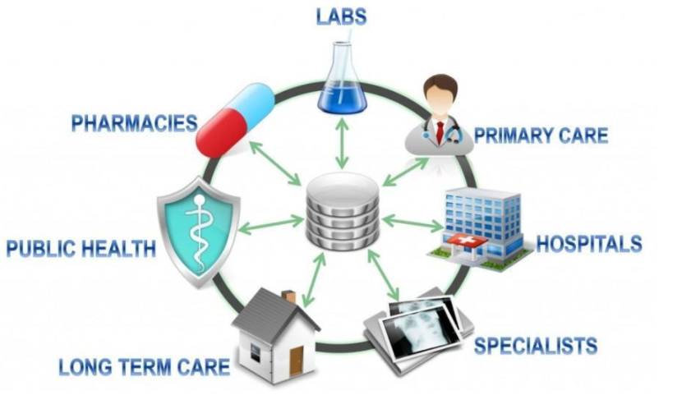
References
Berg, M., Aarts, J., & van der Lei, J. (2019). ICT in health care: sociotechnical approaches. Methods of information in medicine, 42(04), 297-301.

